

PA DRE
SCHOOL # 41
July 21 – August 7, 2026
Commonwealth University-Mansfield Tioga County

Pennsylvania DRE School 41

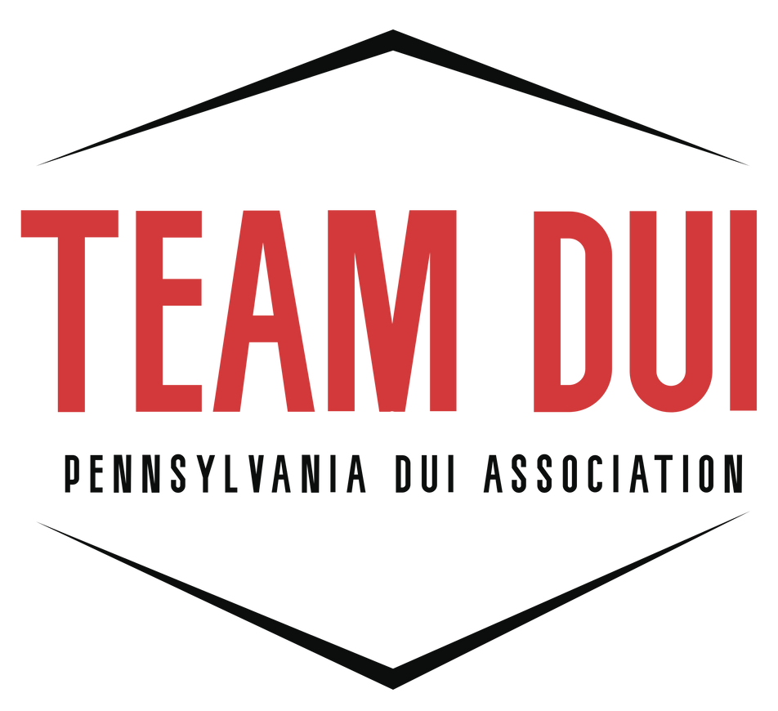

Contact:
Dave Andrascik
PA DECP State Coordinator
Email: paduiman@padui.org
Training Dates, Times and Locations:
July 21, 2026 – 0800-1700 - Mansfield
July 22, 2026 – 0800-1700 - Mansfield
July 23, 2026 – 0800-1700 - Mansfield
July 24, 2026 – 0800-1700 - Mansfield
July 27, 2026 – 0800-1700 - Mansfield
July 28, 2026 – 0800-1700 - Mansfield
July 29, 2026 – 0800-1700 – Mansfield
July 30, 2026 – 0800-1700 – Mansfield
July 31, 2026 – 0800-1700 - Mansfield
August 3, 2026 – 0800-1700 – Philadelphia
August 4, 2026 – 0800-1700 – Philadelphia
August 5, 2026 – 0800-1700 – Philadelphia
August 6, 2026 – 0800-1700 – Philadelphia
August 7, 2026 – 0800-1700 – Philadelphia

Website: https://padui.org/pa-decp/

