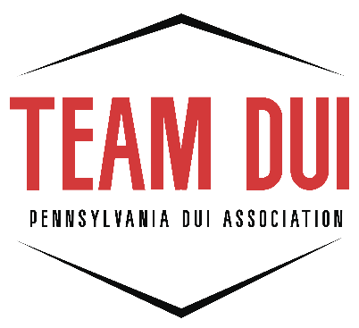
CRN PAW Checklist

SUBMIT NO LATER THAN TWO WEEKS PRIOR TO THE PAW to:
PA DUI Association, 2413 N. Front Street, Harrisburg, PA 17110 or
email to: lpetras@padui.org

Name of CRN PAW Participant: _________________________________________________

_____Register for CRN PAW online (www.padui.org)
_____3 Completed Client Intake Forms (CIFs) (Handwritten copy of all pages of each CIF)
_____3 Completed Worksheets for each CRN submitted (1 for each CIF)
_____3 Client Profile Forms (CPFs) (printout from CRN system)

Submit all required paperwork along with this checklist. Incomplete paperwork will not be accepted.

DUI Coordinator: I have reviewed the attached paperwork being submitted for certification. The above-named individual has my permission to attend the CRN PAW.

Coordinator Signature: _________________________________________________________

