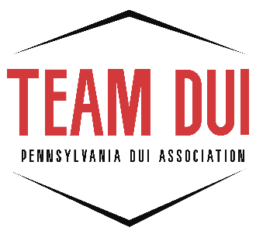

DUI INSTRUCTOR CERTIFICATION/RECERTIFICATION

Certification Process:

1. Observe A COMPLETE (12 ½ - 15 hour) Safe Driving School in person, taught by a certified DUI Instructor
2. Attend the two-day DUI Instructor 1 Workshop
3. Teach one Alcohol Highway Safety School Course in person (with a certified DUI Instructor present)
4. Send all necessary paperwork to the Association prior to the PAW workshop
5. Attend the DUI Performance Analysis Workshop (PAW)
6. Pass the test at the DUI PAW (85% or better)

The steps above must be completed in the order listed.

Individuals who pass the test at the DUI PAW are certified for two years from the date they passed the test. They also must accrue 12 credit hours of approved DUI Instructor continuing education credits by the end of that two-year period, and every two-year period after that as long as they wish to remain certified.

Individuals who fail the exam must go back and attend the DUI Instructor 1 Workshop. They can retest at the end of that workshop and do not need to take the DUI Instructor Performance Analysis Workshop again.

To recertify at the end of the certification period a DUI Instructor recertification form listing credits earned and signed by the DUI Coordinator must be submitted to the Association.

** NOTE: The only exception to the guidelines listed above is that if an individual is both a CRN Evaluator and DUI Instructor, they only need to earn 9 in each for a total of 18 continuing education credits (not 24).

NO outside credits will be accepted for continuing education credits. Certification workshops (DUI I, DUI PAW, CRN I & CRN PAW) do not count towards continuing education credits.

