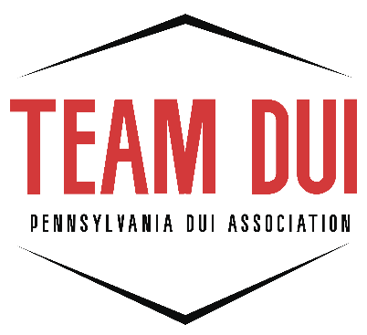

DUI PAW Checklist

Name: _______________________________ County: __________________
Date(s) of AHSS Taught: _____________________________________________
Observer Name(s): __________________________________________________
SUBMIT ALL PAPERWORK NO LATER THAN TWO WEEKS PRIOR TO THE PAW to:
PA DUI Association, 2413 N. Front Street, Harrisburg, PA 17110 or
email to: lpetras@padui.org

_____Register for DUI PAW online (www.padui.org)
_____Comprehensive Course Outline for all Course Modules, signed by DUI Coordinator (this must include all topics covered in each module. For example: If you are listing DUI Law – include the major points within the law that are covered. This can be completed in bullet points)

_____DUI Certification Course Information Form, signed by DUI Coordinator (found in DUI I folder packet)

_____List of pre & post test scores, include average (from Class taught)
_____Completed DUI Instructor Observation Sheets by signed by certified Observer(s) & DUI Coordinator
Incomplete paperwork will not be accepted. Please submit all of the materials from this checklist at one time when submitting paperwork for the DUI PAW.

Coordinator: I have conducted a complete review of all documents submitted by the above-named individual, including this form. I confirm that all required materials are present and that the information provided is accurate, consistent, and compliant with established program standards and requirements. Based on this review, I authorize the individual’s admission into the DUI Instructor PAW.
DUI Coordinator Signature: _____________________________________________________

