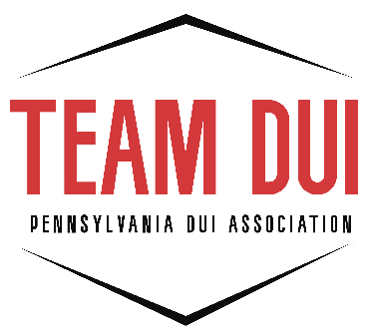

DUI PAW Paperwork Instructions

When submitting paperwork for the DUI PAW, please keep the following in mind:

The following paperwork MUST be submitted at least two weeks prior to the training:

- DUI PAW Checklist, signed by DUI Coordinator

- Comprehensive Course Outline for all Course Modules, signed by DUI Coordinator (this must include all topics covered in each module. For example: If you are listing DUI Law – include the major points within the law that are covered. This can be completed in bullet points)

- DUI Certification Course Information Form, signed by DUI Coordinator: Completed questionnaire regarding the full AHSS Course taught.

- LIST of Student pre & post test scores (include average)

- Course Observation Sheets, signed by the Instructor, Certified Observer(s) and DUI Coordinator: When you teach AHSS Class, the certified Instructor who is observing your class, must complete the Observation sheets.

