

PA DRE
SCHOOL # 41
October 6 – October 23, 2026
Location to be Determined
Bucks County

Pennsylvania DRE School 41

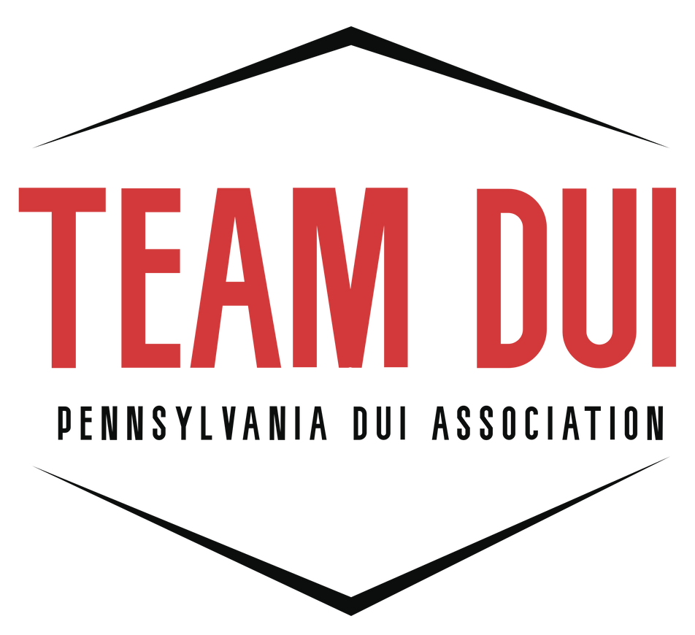

Contact:
Dave Andrascik
PA DECP State Coordinator
Email: paduiman@padui.org
Training Dates, Times and Locations:
October 6, 2026 – 0800-1700 – Bucks County
October 7, 2026 – 0800-1700 – Bucks County
October 8, 2026 – 0800-1700 – Bucks County
October 9, 2026 – 0800-1700 – Bucks County
October 12, 2026 – 0800-1700 – Bucks County
October 13, 2026 – 0800-1700 – Bucks County
October 14, 2026 – 0800-1700 – Bucks County
October 15, 2026 – 0800-1700 – Bucks County
October 16, 2026 – 0800-1700 – Bucks County
October 19, 2026 – 0800-1700 – Philadelphia
October 20, 2026 – 0800-1700 – Philadelphia
October 21, 2026 – 0800-1700 – Philadelphia
October 22, 2026 – 0800-1700 – Philadelphia
October 23, 2026 – 0800-1700 – Philadelphia

Website: https://padui.org/pa-decp/

